Tutorial 4
- Explain what Control Flow Graph (CFG) is.
A graphical representation of a program’s control or logical structure during the execution of programs or application. It consists of Nodes, which represent statements or blocks of statements, and Edges, which represent the flow of control between nodes.

- List and describe the three (3) primitives of Control Flow Graph (CFG).
- A decision is a program point at which the control can diverge (if and case statements)
- A junction is a program point where the control flow can merge (end if, end loop, goto label)
- A process block is a sequence of program statements uninterrupted by either decisions or junctions (straight-line code)

- Explain the following: Chapter 4 slide 13-31
  - Statement Coverage
- Write a test case to cover every Nodes in the Control Flow graph, aka Node Coverage.
- Meaning each statement (that is actually going executed, known as True Path) will have been executed at least once.

  - Branch Coverage
- Write a test case that cover all the branches of predicate node, aka Edge Coverage:
- True and False for each IF-ELSE statement
- Two branches correspond to the condition of loop
- All alternative (default) in SWITCH statement
- Meaning each branch such as True/False in IF-ELSE statement or case/default in SWITCH statement is executed at least once.

  - Branch Condition Coverage
- Write a test case that cover a branch predicate may have more than one condition
- Meaning it requires that each condition will have been TRUE at least once and FALSE at least once.

  - Path Coverage
- Write a test case that ensures every program path or every possible path within the program is executed.
- It is usually impossible to test when loops are present, which makes it impractical especially for large programs. Therefore, there are various strategies designed for identifying useful subsets of paths for testing
- Basis Paths Coverage
- Loop Coverage
- Data Coverage

- What is Cyclomatic Complexity? [Chapter 4 slide 23]
It is a software metric that provides a quantitative measure of logical complexity of a program. It measures the number of independent paths in a basic set or a program.

Calculation Formula:
V(G) = E - N + 2
Where:
- E = Number of Edges
- N = Number of Nodes

Example:
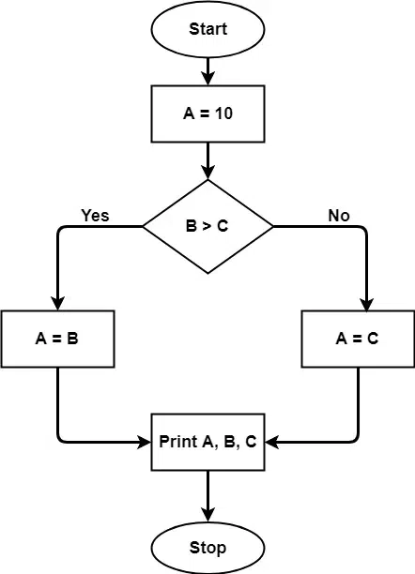
The graph above shows 7 shapes (nodes) and 7 lines (edges), hence Cyclomatic Complexity is [7 - 7 + 2 = 2]. You got 2 independent/basic paths.

- Explain the three steps to identify and define test cases. [Chapter 4 slide 24]
- Draw a corresponding control flow graph
- Draw the graph within the program code
- Find the Cyclomatic complexity, V(G)
- Determine the number of basis path/independent path by finding the number of Edges and Number of Nodes.
- Find basis path/independent paths
- Identify the possible paths
- Prepare test cases
- Design test data to execute each paths

Example:
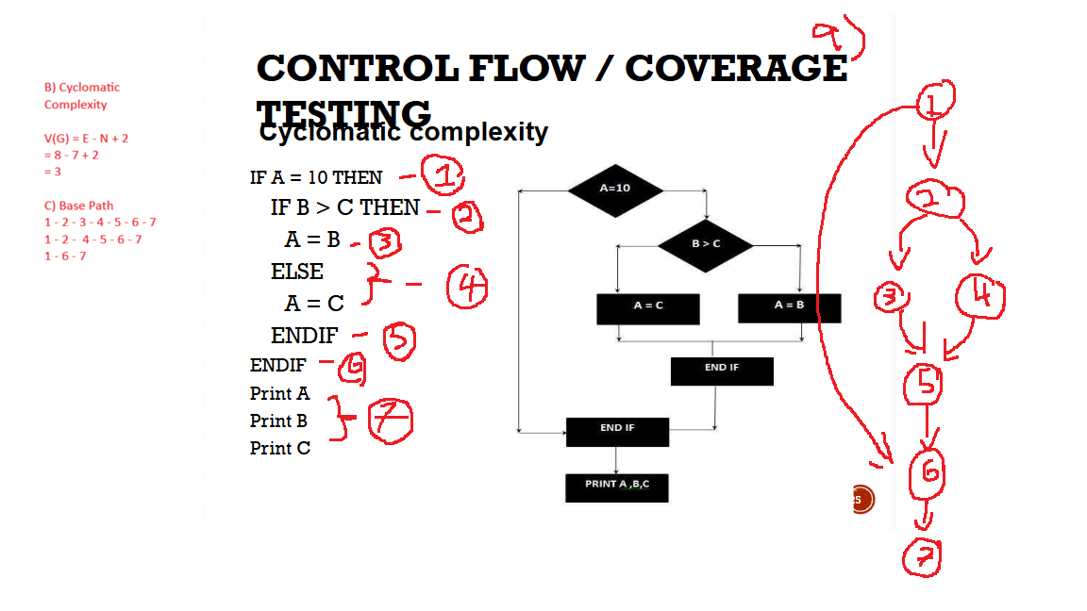

- Describe the four kinds of Loop Testing. [Chapter 4 slide 33-36]
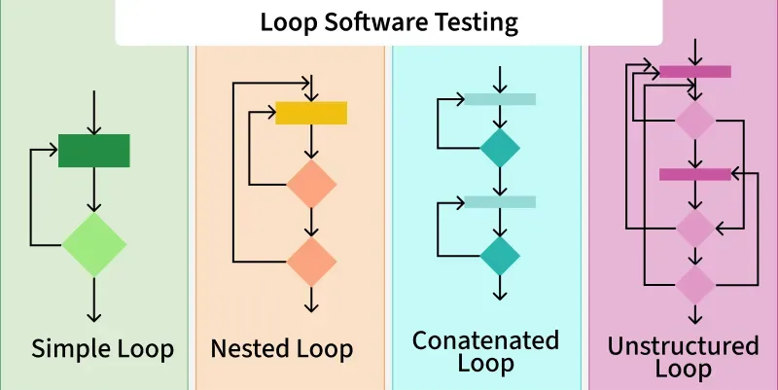
- Simple
- Test the condition of the loop whether the condition is sufficient to terminate loop after some point of time
- Example:
while(condition)
{
statement(s);
}

- Nested
- It is basically one loop inside the other loop, known as Nested loop testing. There can be a finite number of loops inside a loop and there a nest is made. It may be either of any of three such as for, while or do-while. In short, test inner loops first, then outer loops.
- Example:
while(condition 1)
{
while(condition 2)
{
statement(s);
}
}

- Concatenated
- It is basically the loops after the loops, known as Concatenated Loop Testing. If the loops are independent, use simple loop testing. If the loops are dependent, treat it as nested loops.
- Example:
while(condition 1)
{
statement(s);
}
while(condition 2)
{
statement(s);
}

- Unstructured
- A combination of Nested and Concatenated Loop. It is basically a group of loops that are in no order, meaning it avoided in structured programming (eg. goto).
- Example:
while()
{
for()
{}
while()
{}
}

- What are the challenges in White-Box testing? Using your own words, list and explain four challenges in White-Box testing.
- Require programming knowledge and source code assess
- Testers need to have programming knowledge and access to source code to perform tests.
- Overemphasis on internal working
- Testers may focus too much on the internal workings of the software and may miss external issues.
- Cannot detect missing functionalities
- Missing functionalities cannot be detected as the code that exists is tested, meaning white-box testing is only focused on implemented code.
- Test case overhead
- Redesign code and rewrite code needs test cases to be written again.

- Understanding on the requirements
- Understanding on the code
- Lack of resources such as time, skill, person
- Making decision to stop testing

x=0; -1
choice = input.next.charAt (0); // accept input from keyboard -1
switch (choice) -2
{
case ‘1’ : -3
System.out.println("Addition !");
x = x+1;
break;
case ‘2’: -4
System.out.println("Subtraction!");
x = x-1;
break;
case ‘3’ : -5
System.out.println("Multiplication !");
x = x * 1;
break;
default : -6
System.out.println("Please enter a valid choice !");
} endswitch -7
return 0; -8

- Draw the Control Flow Graph for the above codes.
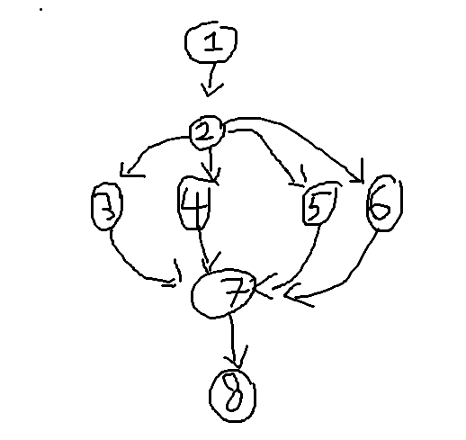

- Calculate the Cyclomatic Complexity. You must show the working steps.
V(G) = E - N + 2
= 10 - 8 + 2
= 4

- Identify the Basis Path.
Path 1: 1 - 2 - 3 - 7 - 8
Path 2: 1 - 2 - 4 - 7 - 8
Path 3: 1 - 2 - 5 - 7 - 8
Path 4: 1 - 2 - 6 - 7 - 8

- Identify the path for Branch Coverage.
Path 1: 1 - 2 - 3 - 7 - 8
Path 2: 1 - 2 - 4 - 7 - 8
Path 3: 1 - 2 - 5 - 7 - 8
Path 4: 1 - 2 - 6 - 7 - 8

x=true; -1
Do
{ -2
gender = input.next.charAt (0); // accept input from keyboard -3

if(Character.isDigit(gender) != True) //check whether the character is numeric digit
{ -4
switch (gender)
{ -5
case ‘M’ :
System.out.println("Hello, Gentleman !");
x = false;
break; -6
case ‘F’ :
System.out.println("Hello, Lady!");
x = false;
break; -7
default :
System.out.println("Please enter a valid gender !"); -8
} -9
} -10
}while(x); -11
return 0; -12

- Draw the Control Flow Graph for the above codes.
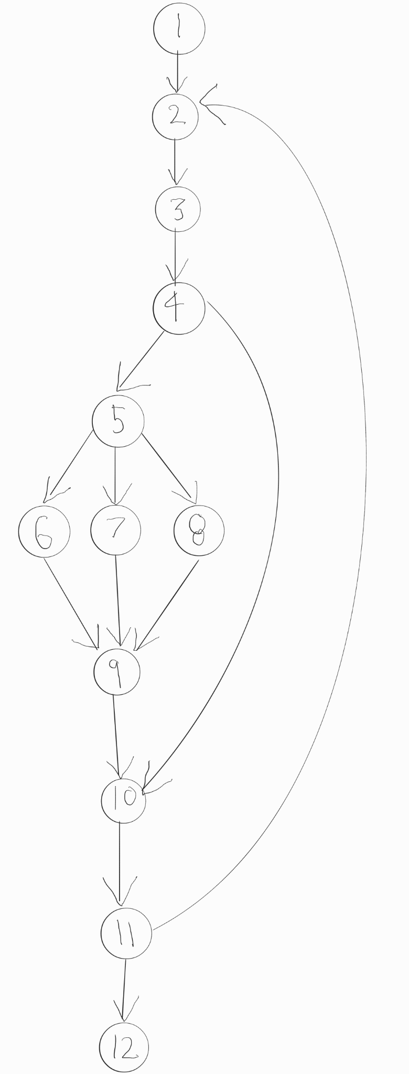

- Calculate the Cyclomatic Complexity. You must show the working steps.

V(G) = 15-12+2 =5

- Identify the Basis Path.

- 1-2-3-4-5-6-9-10-11-12
- 1-2-3-4-5-7-9-10-11-12
- 1-2-3-4-5-8-9-10-11-12
- 1-2-3-4-10-11-12
- 1-2-3-4-10-11-2-3-4-10-11-12

- Identify the path for Branch Coverage.

- 1-2-3-4-5-6-9-10-11-12
- 1-2-3-4-5-7-9-10-11-12
- 1-2-3-4-5-8-9-10-11-12
- 1-2-3-4-10-11-12

10.
x = true; –1
while (x) –2
{
num = input.nextInt(); // accept input from keyboard –3
if (num <=0) –4
System.out.println(“Invalid number !”); –5
–6 endif
balance = num % 2; –7
switch (balance) –8
{
case 1 : –9
System.out.println("You have entered an odd number !");
x = false; –10
break;
default : –11
if(balance ==2) –12
System.out.println("You have entered an even number !"); –13
else
System.out.println("Please enter a valid integer number !"); –14
–15 endif
} –16 switch
} –17 endwhile
return 0; –18

- Draw the Control Flow Graph for the above codes.
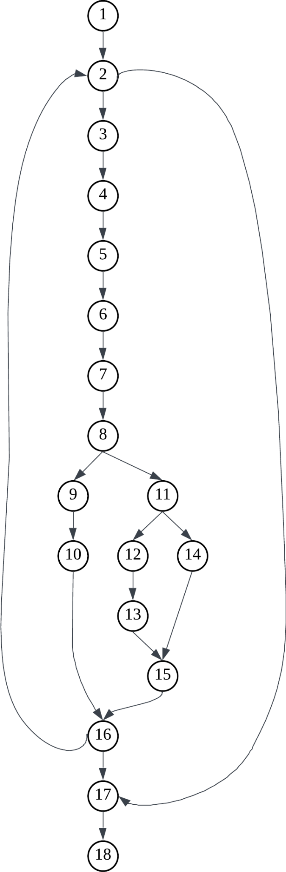

- Calculate the Cyclomatic Complexity. You must show the working steps.
V(G) = E - N + 2
= 21 - 18 + 2
= 5

- Identify the Basis Path.
- 1-2-3-4-5-6-7-8-9-10-16-17-18
- 1-2-3-4-5-6-7-8-11-12-13-15-16-17-18
- 1-2-3-4-5-6-7-8-11-14-15-16-17-18
- 1-2-3-4-5-6-7-8-9-10-16-2-3-4-5-6-7-8-9-10-16-17-18
- 1-2-17-18

- Identify the path for Statement Coverage.
- 1-2-3-4-5-6-7-8-9-10-16-17-18
- 1-2-3-4-5-6-7-8-11-12-13-15-16-17-18
- 1-2-3-4-5-6-7-8-9-10-16-2-3-4-5-6-7-8-9-10-16-17-18

